Digital Training Academy: Cybersecurity
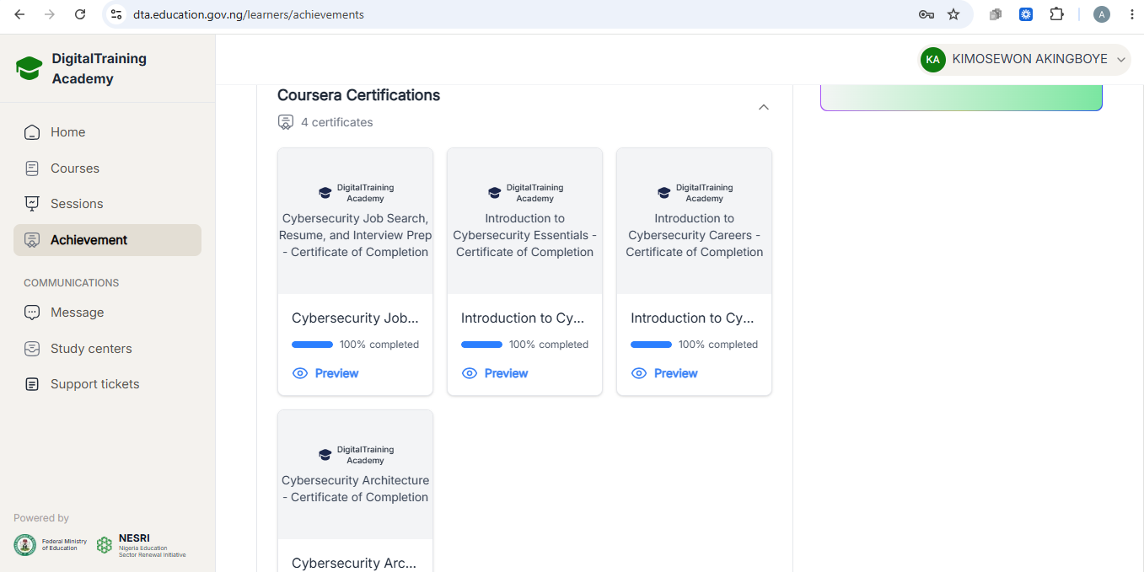

IBM Cybersecurity Analyst Professional Certificate on Coursera
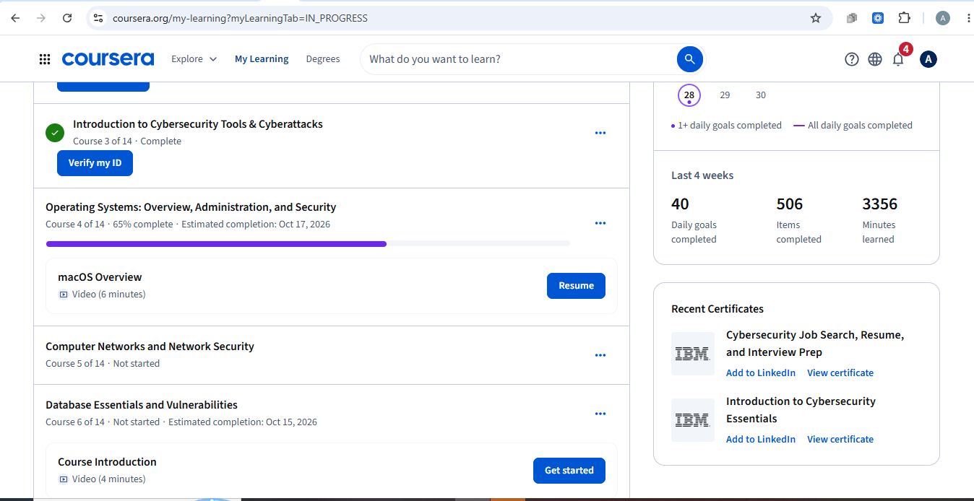

3MTT Fellow: Cybersecurity


Junior Cybersecurity Analyst at CISCO Networking Academy
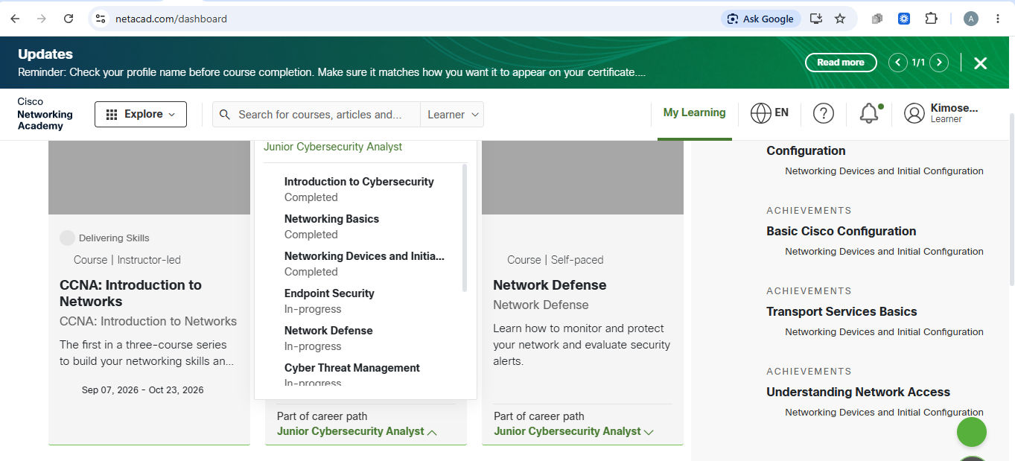

Current Laptop


